**GDetect**:

**Detecting Duplicate and Fraudulent GCash Entries using Deep Learning Methods**

A Proposal by the Team:

**The Exclusives**

**Team Information**

|  |  |
| --- | --- |
| **Country** | Philippines |
| **Category** | Junior |
| **Challenge Statement** | No.4, GCash |
| **Team Name** | The Exclusives |

**Content Outline**

|  |  |  |  |  |
| --- | --- | --- | --- | --- |
|  | **Full Name** | **Email Address** | **Institution** | **LinkedIn Profile URL** |
| **Member 1** | Brymer Bernard R. Meneses | meneses.brymer  @gmail.com | Manaoag National High School Senior High School | https://www.linkedin.com/in/brymer-meneses-9552711b4/ |
| **Member 2** | Paul T. Jimenez | hannaagarcia08  @gmail.com | Manaoag National High School Senior High School | None |
| **Member 3** | Gillian Hannah G. Llagas | hannaagarcia08  @gmail.com | Manaoag National High School Senior High School | None |
| **Member 4** | Julie-Mark S. Cabingas | juliemark.cabingas  @gmail.com | Manaoag National High School Senior High School | None |
| **Member 5** | Natasha Ann Maranon | maranonnatasha  @gmail.com | Manaoag National High School Senior High School | None |

|  |  |
| --- | --- |
| **Content Outline** | **Page No.** |
| **Significance of Problem** | **1** |
| **Solutions Introduction** | **2** |
| **Impact of Solution** | **2** |
| **Deep Dive into Solution** | **4** |
| **Architecture of Solution** | **5** |
| **Going further** | **5** |

**Significance of the Problem**

*Page 1*

**How does the problem impact the area of focus, e.g. how is this problem affecting the target audience mentioned in the challenge statement?**

The outbreak of the COVID-19 gave rise to different methods to address the daily needs of the society one of which is through online banking. GCash is a popular application that is used in order to pay bills, purchase different goods and services and it even allows the user to send or receive money. The rise in the popularity of the said application and the increase in the number of users caused problems in terms of the authenticity of the users' profiles. This, in turn, will cause security issues and the probability of being scammed by those unauthentic users. Although there exist verification and security processes before using the application and there are assurances by the Customer Protect of GCash that the customers "will not be held liable for unauthorized transactions made", this proposal seeks to further bolster the security offered in the verification process of GCash.

This proposal will incorporate different methods to solve the fraudulent user verification. This includes countermeasures which uses Deep Learning Methods in order to detect whether the pictures used in the currently existing verification process is not edited or whether it has been made through the use of computer which will be tagged as a computer-generated file. This will help the currently existing verification process to avoid accepting pictures that are not authentic, thus reduces the probability of frauds in accessing the application. This proposal will also require selfie of the user together with their ID. Another importance of proposal is to create an algorithm operated by artificial intelligence to identify and quantify the similarities between the picture in the ID and the selfie of the user. This will help the company to secure and maintain its stand against frauds. All these things considered, the significance of this study is to give additional security features on the verification process in order to solve the issue about fraudulent user verifications and to give security to the users of the application as well as the company.

**Solutions Introduction**

*Page 2*

**What is your solution and how does it work? Discuss main features clearly.**

When a GCash user attempts to verify their account, they are required to upload two pictures: a picture of a Valid ID and a selfie with that user holding their ID. The goal of this process is to see if the face of the user bear some resemblance to their picture in the ID.0

To combat this, we have employed a facial similarity algorithm to quantify the resemblance of the picture in the ID with the selfie of the user. By saving these vector embeddings on an EC2 Instance, we will be able to use these embeddings to avoid duplicate entries. Because whenever a new user wants to verify their account, vector embeddings will be extracted from the image of their face, and these vector embeddings will be compared to other vector embeddings that are already stored in the database inside the EC2 instance. This is done by using cosine similarity which allows us to determine the similarity of two vector embeddings.

This avoid the problem with duplicated entries. We also employ two Convolutional Neural Networks which will be used to detect if the image being sent been edited or has been computer generated. All of these features will be coded in Python, using the PyTorch Deep Learning Framework.

**Impact of Solution**

**How does your solution benefit the society / the target audience?**

With the growing automation of transaction in our daily lives, it lessens the need to go through various agency to verify our identity. The automation method allows individuals to conduct any transaction with almost any type of technology such as cellular phone. However, with the common this practices, people has also come up on taking advantage of it. Identity theft are one of the ways that people use to steal private data from user to commit fraud.

In the last years there have been many approaches to deal with this matter, one of which is biometrics. Biometrics security are features that scan the body measurements and calculations related to human characteristics. With the integration of Artificial intelligence into the system, the security increases. One of its application is the use of facial biometrics since facial recognition are one of the most commonly used in verification of id. Upon creation of the account, the system will require the user to use an image that will be save in the database as the personal id. With this, the user’s personal id image will be used to compare with the submitted selfie. The process is done by programming AI to analyze the facial features of the two image and verify the authenticity. This method is beneficial to the users since there is no need for verifications codes or verification from third party system which then results to a faster and smoother transaction. Aside from that, it also secures the user from unwanted transaction. Another approach presented using AI is by training it to identify if the images are computer generated which prevents automated plug-ins from suspicious sources.

*Page 3*

**Why is your solution a good solution? How is it better than existing solutions in the market / competitors?**

The proposed solution offers more security to the user, as well as to the business owners from malicious or false transactions. Aside from that, the user can conduct multiple transactions at a much faster rate which res ults to increases of spending.

**What is your solution’s competitive advantage / unique selling point?**

Since our solution, uses deep learning methods at the core of its algorithm, the accuracy of our solution can be vastly improved with the introduction of new data to the training process

of the various Convolutional Neural Networks that are used in the algorithm. Numerous studies have shown that with enough data and parameters, a Neural Network can beat a human at certain tasks, and we believe that the algorithm we developed can beat a human in identifying fraudulent entries given enough data.

*Page 4*

**Deep Dive into Solution**

*Page 4*

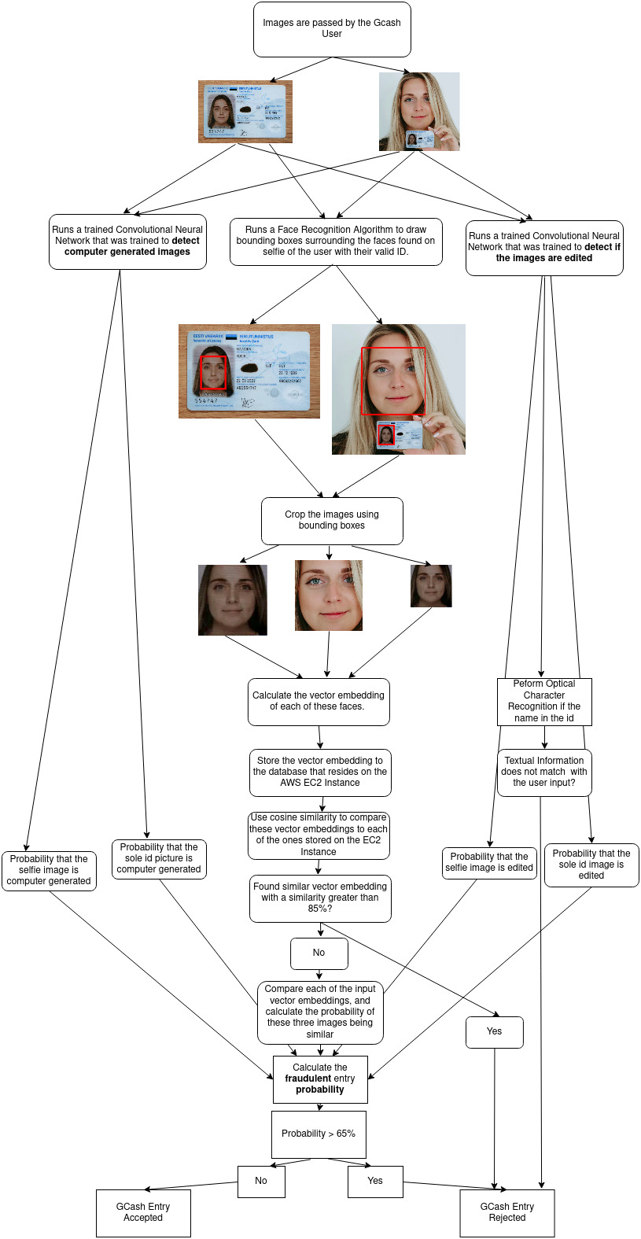

**Architecture of Solution**

*Page 5*

There are 3 AWS services used in this algorithm, the front end of the application will be developed in React JS and will be deployed using **AWS Lambda.** The numerous Convolutional Neural Networks will be trained and deployed at **AWS SageMaker.** The main backend of our solution that will handle all the computations, image augmentation and house the vector embeddings, will be deployed at an **AWS EC2** instance. Together these three will make up the whole solution of our proposal.

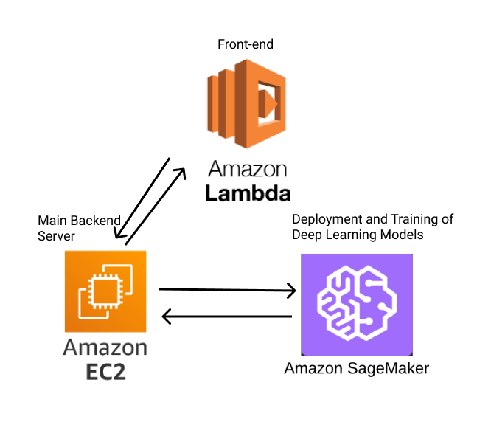

**Going further**

It is important to explore each phase of the creation of the solution in detail. Given more time and financial resources to improve and review possible problems of this proposal, continuous mapping, analysis, and redesigning of the process are the best practices to address those issues. To begin with, the team will see to it that there is detailed documentation of variations, barriers, issues, solutions, and implementation of the plans and a focus on the assessment and monitoring methods throughout the process. In addition to this, if elimination of unsuitable options by a screening process is needed, the team will need to identify if the solution meets all the necessary and sufficient conditions and if they are feasible or not. In terms of the analysis of the problem, using a swim lane diagram to investigate problems such as which of the steps creates a bottleneck; where do costs go up and quality goes down. The team will also conduct impact, risk, failure mode, and effects analysis to spot possible risks and points of failure within the improvement of the solution.

*Page 6*

The team will sustainably manage the solution, including the stakeholders and people involved, as well as any political, cultural, and cognitive dimensions which the proposal may bring with it. Growth by innovation comes from products or services, finding customers, and communicating marketing messages more clearly to target markets. When it comes to the commercialization of the team’s idea, these are the key steps that will be applied. The first is to find business potential and relate it to the company’s needs. While it may be a problem that customers do not always know what they need, the key to seeing the right opportunities can be achieved through monitoring the market, basic research, and customer behavior. The team will also continually take a hard look internally at the solution and understand how hidden assets in terms of knowledge, access, and capabilities can be leveraged to solve customer problems. Lastly is to conduct a technical development to fill gaps in the solution and how it solves the problem. The team will build a quick prototype and gets as much feedback from potential customers as possible to make it better and develop a practical marketing strategy. Different skills and opinions from the participation of technology developers, start-up companies, experts on the raw material chain, and end-users are essential for this process. with it. Growth by innovation comes from products or services, finding customers, and communicating marketing messages more clearly to target markets. When it comes to the commercialization of the team’s idea, these are the key steps that will be applied. The first is to find business potential and relate it to the company’s needs. While it may be a problem that customers do not always know what they need, the key to seeing the right opportunities can be achieved through monitoring the market, basic research, and customer behavior.

The team will also continually take a hard look internally at the solution and understand how hidden assets in terms of knowledge, access, and capabilities can be leveraged to solve customer problems. Lastly is to conduct a technical development to fill gaps in the solution and how it solves the problem. The team will build a quick prototype and gets as much feedback from potential customers as possible to make it better and develop a practical marketing strategy. Different skills and opinions from the participation of technology developers, start-up companies, experts on the raw material chain, and end-users are essential for this process. a hard look internally at the solution and understand how hidden assets in terms of knowledge, access, and capabilities can be leveraged to solve customer problems. Lastly is to conduct a technical development to fill gaps in the solution and how it solves the problem. The team will build a quick prototype and gets as much feedback from potential customers as possible to make it better and develop a practical marketing strategy. Different skills and opinions from the participation of technology developers, start-up companies, experts on the raw material chain, and end-users are essential for this process.quick prototype and gets as much feedback from potential customers as possible to make it better and develop a practical marketing strategy. Different skills and opinions from the participation of technology developers, start-up companies, experts on the raw material chain, and end-users are essential for this process.

*Page 7*